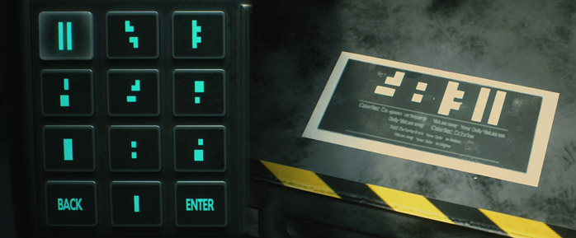

Puzzle 1: (Resident Evil 2 remastered) entering symbols in the right order into a computer to unlock doors or the next puzzles.

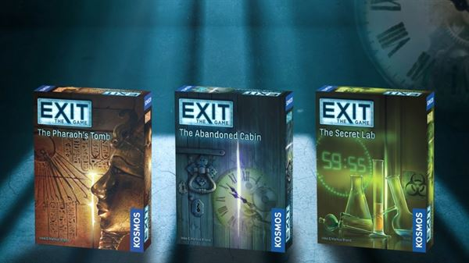

Puzzle 2: (The abandoned cabin)- no photos available for the puzzles, unfortunately. Colour based puzzle where you receive a written hint and multiple coloured objects. By using general knowledge, the puzzle is solvable. Example: take away the red from the colour of the skull. The newly obtained colour of the skull, add it to the colour of the pen.

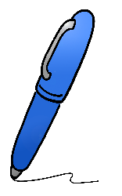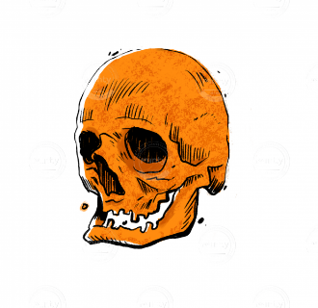

- Red = Yellow + Yellow = Green

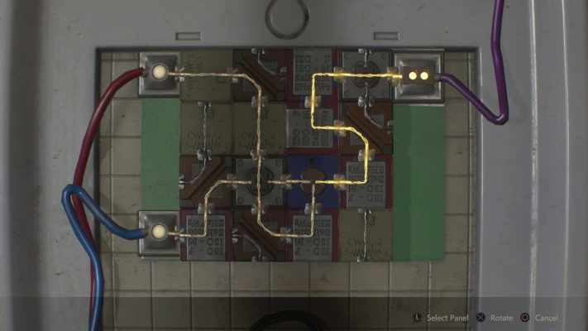

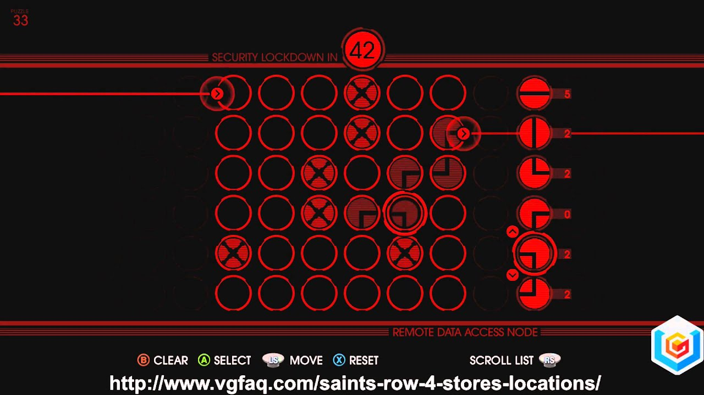

Puzzle 3: (Resident Evil 2 R. and Saints Row 4) Connecting cables/ lines of different shapes in order to make them reach from an end to the other.

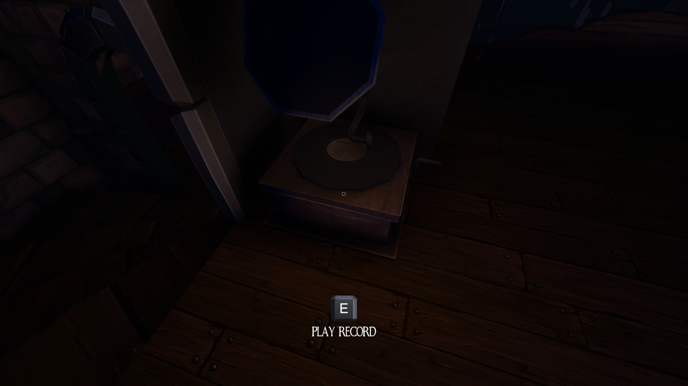

Hints 1: (We were here) Diegetic sounds (all sounds that have a source on the screen) - a good way to avoid excessive written messages in puzzle games is by using audio recordings. 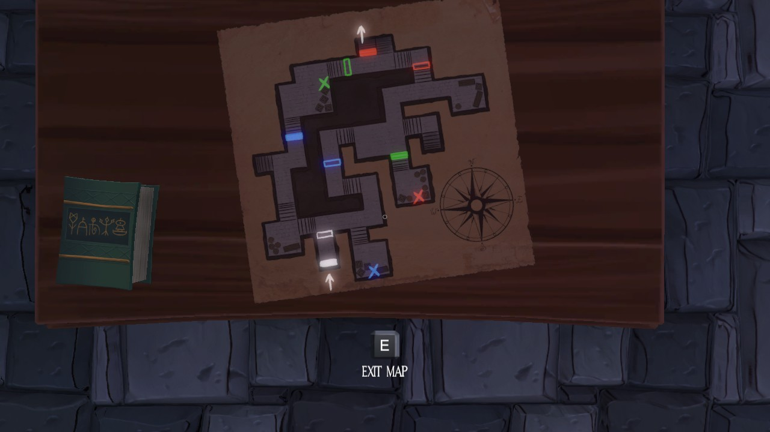

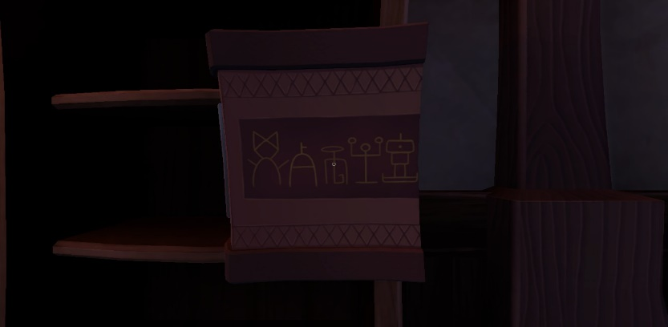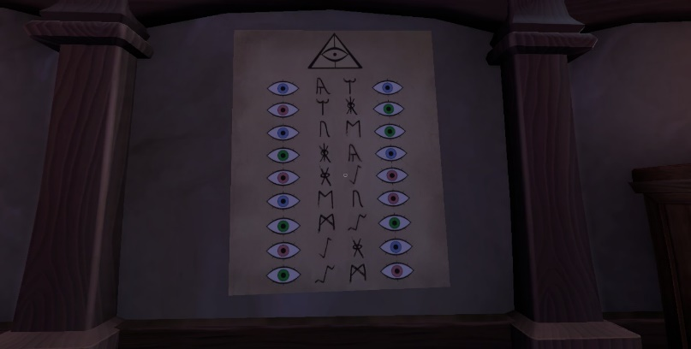Hint 2: (We were here) Turning off the light allows the players to unlock new information. (glow in the dark clues)

Hints 3: (We were here) Visual, diegetic hints.